# Categories

## Common fields for all categories

|  |  |
| --- | --- |
| Field name | Comment |
| Manufacturer[1] | Complex field. Contains dropdown box with |
| Model1 |  |
| Creator | Will be filled in automatically. Could not be edited. |
| Version | Version of equipment item modification. Will be handled automatically by system. Could not be edited. Starts from 1. |
| Modification date |  |
| Owner |  |
| Serial number |  |
| Barcode |  |
| Location |  |
| State | Dropdown box with “Normal”, “Broken” and “Lost” values |
| Guarantee expiration |  |
| Office | Default value “Kharkov”. Available choices can be populated. |
| Accounting Inventory Code |  |
| Comments |  |

Assuming, that “Socket type”, “MAC address”, “Return date”, “Revision date” fields from old Inventory tool are not needed in the new one.

## Debug tool

No custom fields. Tool type is already covered by Manufacturer field.

## TV

No custom field. “Display type” and “Display ports” field are not needed. “Diagonal” field value should be added in “Model” field.

## STB

|  |  |
| --- | --- |
| Field name | Comment |
| Receiver CA ID |  |
| Secure | Checkbox field. |
| Service provider | User can select one of already existing choices or enter new value. New service provider name will available for all users after STB item is added to DB. |

## RCU

No custom fields.

## Smartcard

|  |  |
| --- | --- |
| Field name | Comment |
| Serial number | This field should be used as **Smartcard ID** |
| Service provider | User can select one of already existing choices or enter new value. New service provider name will available for all users after STB item is added to DB. Same behavior as “Service provider” field in STB category. |

## Storage drive

|  |  |
| --- | --- |
| Field name | Comment |
| Storage Type | Dropdown box with “External HDD”, “Internal HDD”, “Flash drive” and “Mobile rack” values. |
| Capacity | Integer field, gigabytes |
| Interfaces | Check box array with “USB”, “mini-USB”, “eSATA”, “SATA” and “IDE” values. |

## Test equipment

|  |  |
| --- | --- |
| Field name | Comment |
| Type | User can select one of already existing choices or enter new value. New service provider name will available for all users after Test equipment item is added to DB. |
| Calibration date |  |

## Cable

|  |  |
| --- | --- |
| Field name | Comment |
| Title |  |

## Adapter

|  |  |
| --- | --- |
| Field name | Comment |
| Title |  |

## Video capture card

TBD

## SAGE

TBD

## Transformer step-down

No custom fields.

## Transformer isolation

No custom fields.

## Network equipment

No custom fields.

## Front panel

|  |  |
| --- | --- |
| Field name | Comment |
| Title |  |

## Headphones

|  |  |
| --- | --- |
| Field name | Comment |
| Has microphone | Checkbox field. |

## IR Receiver

No custom fields.

## CD

No custom fields.

## Microphone

No custom fields.

## Streaming equipment

No custom fields.

## PSU

|  |  |
| --- | --- |
| Field name | Comment |
| Socket type | Dropdown field with “UK, “US” and “Europe” values. |
| Input current | Integer field, volts. |
| Output current | Integer field, volts. |
| Title |  |

## Red Rat

No custom fields.

## USB hub

No custom fields.

## SMART Box

No custom fields.

## Smartcard reader

No custom fields.

## Web camera

No custom fields.

# REST API Schema

## Manufacturers

|  |  |  |  |  |  |
| --- | --- | --- | --- | --- | --- |
| Method | URL | Request body | Response body | HTTP codes | Action |
| GET | /manufacturers |  | List of manufacturers | 200 |  |
| GET | /manufacturers/approved |  | List of approved manufacturers | 200 |  |
| GET | /manufacturers/unapproved |  | List of unapproved manufacturers | 200 |  |
| GET | /manufacturers/<GUID> |  | Manufacturer with provided GUID | 200  400 |  |
| POST | /manufacturers | {“manufacturer”:”new manufact. name”} |  | 200  400 | Request new manufacturer |
| POST | /manufacturers/approved | {“manufacturer”:”new manufact. name”} |  | 200  400 | Create approved manufacturer name. Admin only |
| PUT | /manufacturers/<GUID> | {<manufacturer-object>} |  | 200  400 | Update manufacturer name |
| PUT | /manufacturers/approve |  |  | 200  400 | Approve all manufacturer. Admin only |
| PUT | /manufacturers/approve/<GUID> |  |  | 200  400 | Approve specific manufacturer by GUID. Admin only |
| DELETE | /manufacturers/<GUID> |  |  | 200  400 |  |

## Locations

|  |  |  |  |  |  |
| --- | --- | --- | --- | --- | --- |
| Method | URL | Request body | Response body | HTTP codes | Action |
| GET | /locations |  | List of location objects | 200 |  |
| GET | /locations/<GUID> |  | Location object | 200  400 |  |
| POST | /locations | Location object |  | 200  400 | Create new location. Admin only |
| PUT | /locations/<GUID> | Location object |  | 200  400 | Update location. Admin only |
| DELETE | /locations/<GUID> |  |  | 200  400 | Delete location which does not contain any equipment. Admin only |

## Offices

|  |  |  |  |  |  |
| --- | --- | --- | --- | --- | --- |
| Method | URL | Request body | Response body | HTTP codes | Action |
| GET | /offices |  | List of office objects | 200 |  |
| GET | /offices /<GUID> |  | Office object | 200  400 |  |
| POST | /offices | Office object |  | 200  400 | Create new office. Admin only |
| PUT | /offices/<GUID> | Office object |  | 200  400 | Update office name. Admin only |
| DELETE | /offices/<GUID> |  |  | 200  400 | Delete office which does not contain any equipment. Admin only |

## Service providers

|  |  |  |  |  |  |
| --- | --- | --- | --- | --- | --- |
| Method | URL | Request body | Response body | HTTP codes | Action |
| GET | /service-providers |  | List of Service provider objects | 200 |  |
| GET | /service-providers/<GUID> |  | Service provider object | 200  400 |  |
| POST | /service-providers | Service provider object |  | 200  400 | Create new service provider |
| PUT | /service-providers/<GUID> | Service provider object |  | 200  400 | Update service provider name |
| DELETE | /service-providers/<GUID> |  |  | 200  400 | Delete service provider which does not belong to any equipment |

## Users

|  |  |  |  |  |  |
| --- | --- | --- | --- | --- | --- |
| Method | URL | Request body | Response body | HTTP codes | Action |
| GET | /users |  | List of users | 200 |  |
| GET | /users/<GUID> |  | User object | 200  400 |  |
| POST | /users/sync |  |  | 200 | Re-sync users from AD. Admin only |

## Statuses

|  |  |  |  |  |
| --- | --- | --- | --- | --- |
| Method | URL | Request body | Response body | HTTP codes |
| GET | /statuses |  | List of status objects | 200 |
| POST | /statuses | Status object |  | 200  400 |
| PUT | /statuses/<GUID> | Updated status object |  | 200  400 |
| DELETE | /statuses/<GUID> |  |  | 200  400 |

## Models

|  |  |  |  |  |  |
| --- | --- | --- | --- | --- | --- |
| Method | URL | Request body | Response body | HTTP codes | Action |
| GET | /models |  | List of models | 200 |  |
| GET | /models/approved |  | List of approved models | 200 |  |
| GET | /models/unapproved |  | List of unapproved models | 200 |  |
| GET | /models/<GUID> |  | Model with provided GUID | 200  400 |  |
| POST | /models | {“model”:”new model name”} |  | 200  400 | Request new model |
| POST | /models/approved | {“model”:”new model name”} |  | 200  400 | Create approved model name. Admin only |
| PUT | /models/<GUID> | Model object |  | 200  400 | Update model name |
| PUT | /models/approve |  |  | 200  400 | Approve all models. Admin only |
| PUT | /models/approve/<GUID> |  |  | 200  400 | Approve specific model by GUID. Admin only |
| DELETE | /models/<GUID> |  |  | 200  400 |  |

## Categories

|  |  |  |  |  |  |
| --- | --- | --- | --- | --- | --- |
| Method | URL | Request body | Response body | HTTP codes | Action |
| GET | /categories |  | List of categories | 200 |  |
| GET | /categories/<GUID> |  | Category object | 200  400 |  |
| POST | /categories | Category object |  | 200  400 | Admin only |

## Equipment

|  |  |  |  |  |
| --- | --- | --- | --- | --- |
| Method | URL | Request body | Response body | HTTP codes |
| GET | /equipment |  | List of equipment objects | 200 |
| GET | /equipment/<GUID> |  | List of equipment objects | 200 |
| GET | /equipment/category/<category-GUID> |  | List of equipment objects | 200 |
| GET | /equipment/user/<user-GUID> |  | List of equipment objects | 200 |
| GET | /equipment/status/<status-GUID> |  | List of equipment objects | 200 |
| GET | /equipment/bar/<string> |  | List of equipment objects | 200 |
| GET | /equipment/search?<query-string>[2] |  | List of equipment objects | 200 |
| POST | /equipment | Equipment object |  | 200  400 |
| PUT | /equipment/<GUID> | Equipment object |  | 200  400 |
| DELETE | /equipment/<GUID> |  |  | 200  400 |

# Mockups

## Sign in page

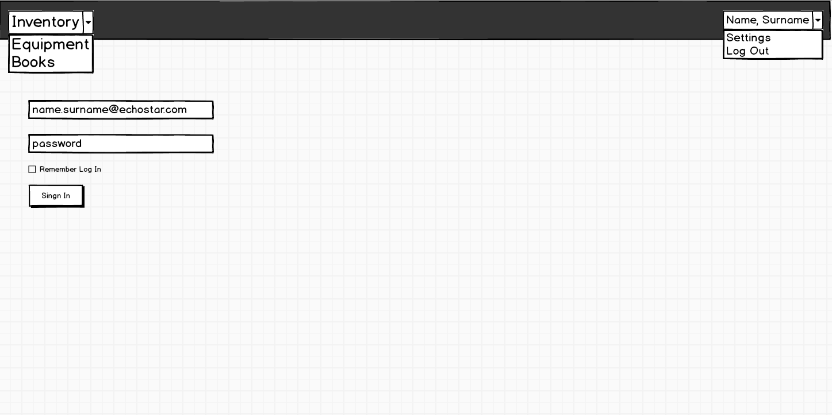

## Equipment

### Equipment – folded filter bar

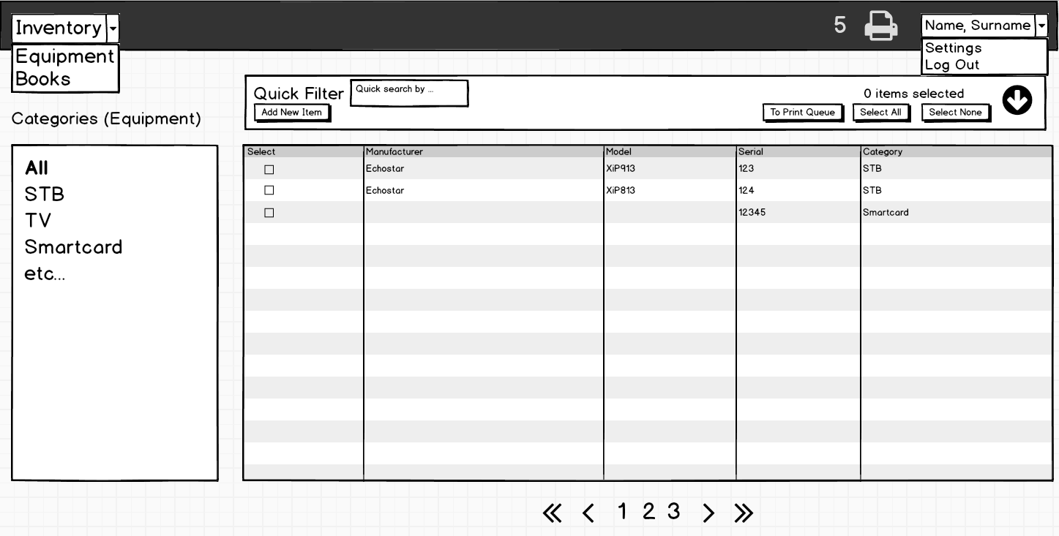

### Equipment – expanded filter bar

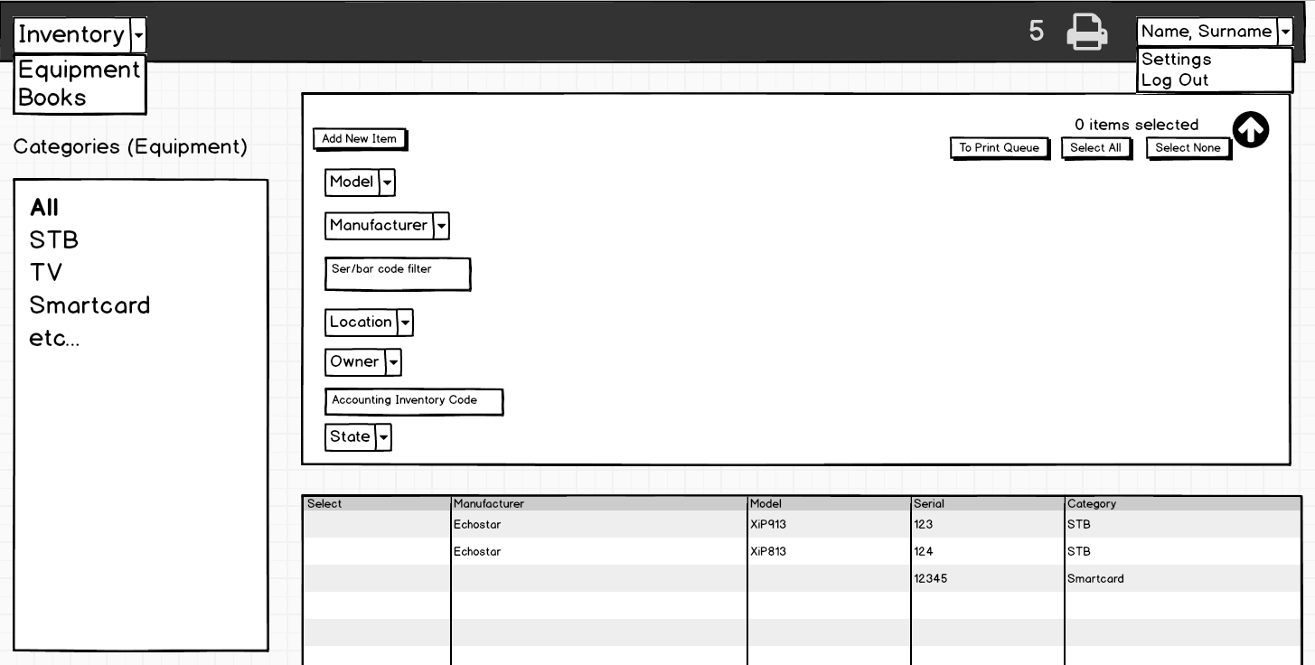

## Settings page

### Locations and other item types

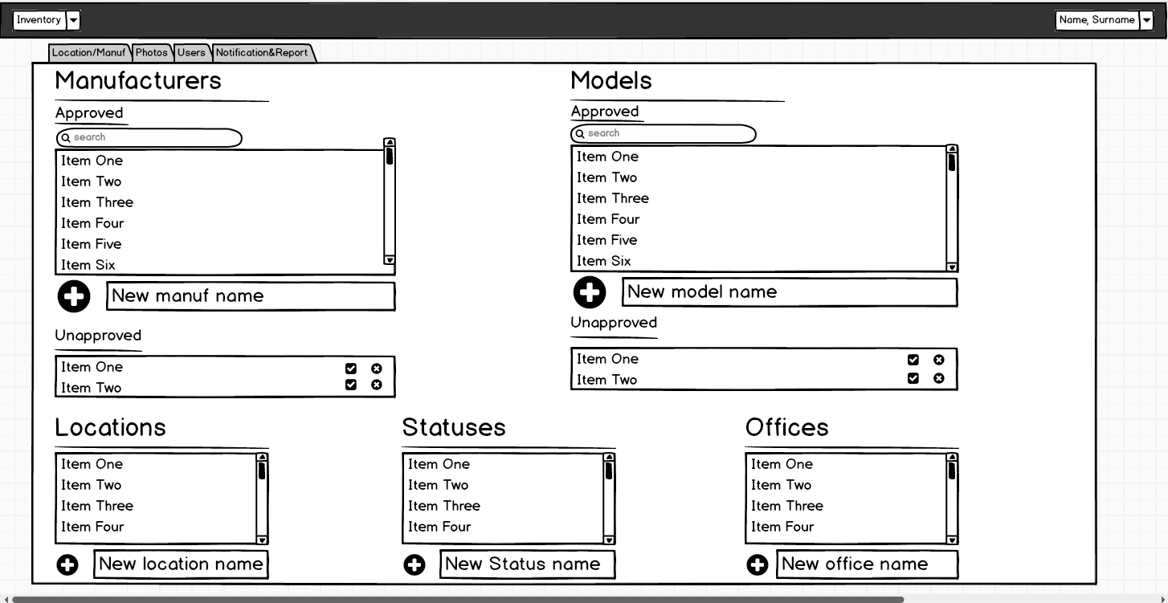

### Notifications and Reports

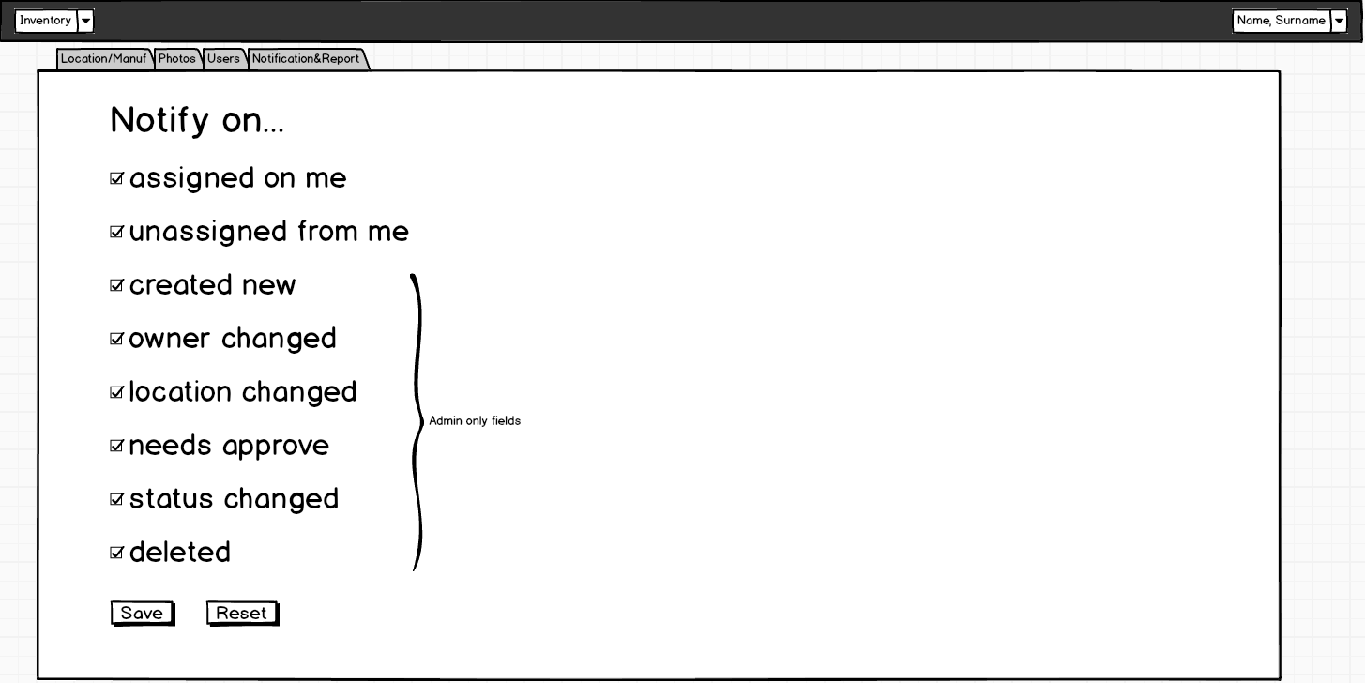

### Photos

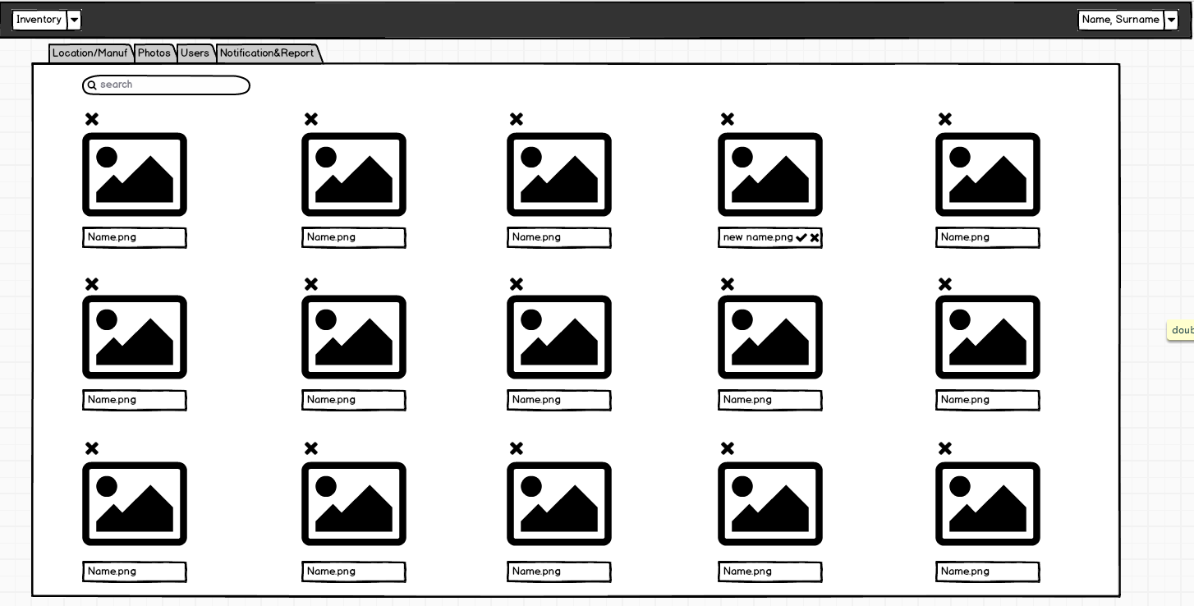

### Permissions

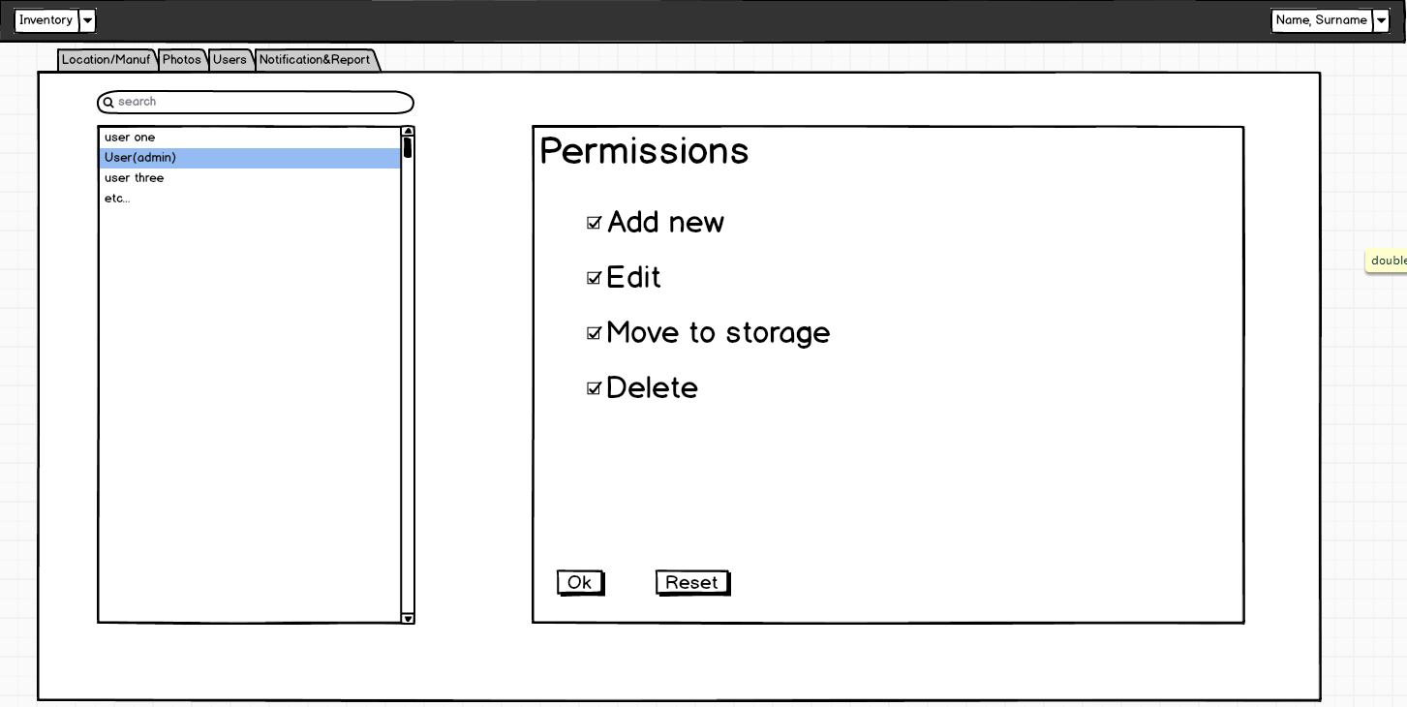

1. This field is applicable to all categories except Cables, Smartcard, Adapter, PSU and Front panel.
2. For query string specification please refer [RFC3986](https://tools.ietf.org/html/rfc3986#section-3.4)